*Tableau Dashboard Documentation XIAOLU LI*

1. Introduction

*Definitions*:

Tableau Dashboards are compact views consisting of many different visualizations that aim to help users to quickly grasp the main insights to be showcased. Since the analysis report contains visualizations that might not be easily interpret to a wide range of viewers, our Tableau Dashboards are created to highlight different answers to frequently asked topics.

*Implementation*:

With how our datasets are structured, it is crucial to clean the data to remove null and misleading data before using it. In this documentation, we will provide in-depth details to the formation of the Dashboards.

*Data sources:* Fitness Track Products E-commerce:

<https://www.kaggle.com/datasets/devsubhash/fitness-trackers-products-ecommerce>

2. Dashboard

This dashboard is designed to analyze the relationship between product details of different brands and their popularity. Showcase details for each brand by correlating the brand's Price, Device type, and Battery life with user ratings.

Dashboard:

<https://public.tableau.com/views/fitness_trackers_dashboard/1?:language=zh-CN&:display_count=n&:origin=viz_share_link>

1. Data preparation.

Process raw data through python to understand data type, content, and labels. Handle data null issues, same string, and data format. This processed data is more convenient when using tableau.

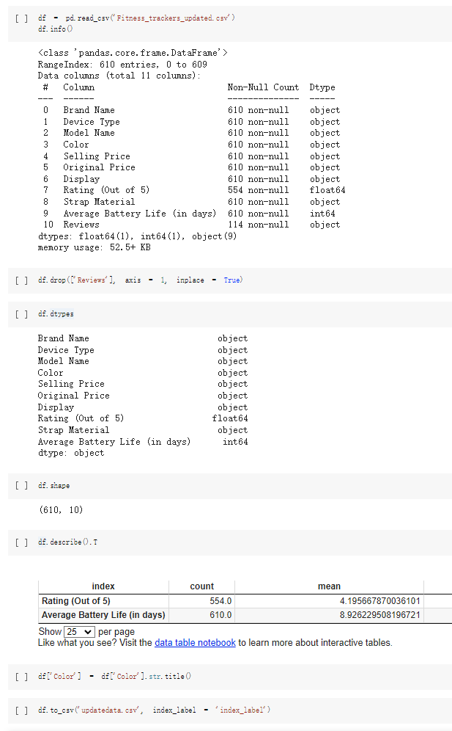

2. Dashboard

The dashboard for Brands’ details:

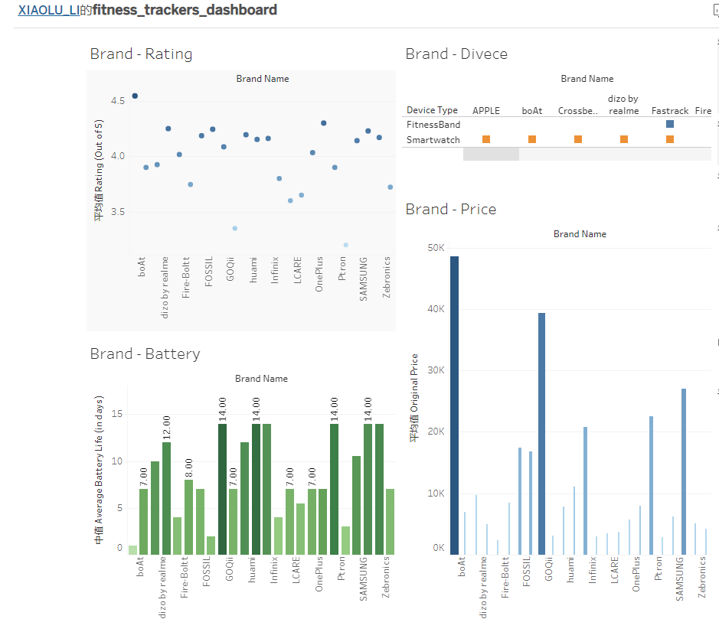

1st Graph

The size of the blue dot represents the average rating of the brand, and the darker the color, the higher the average rating of the brand. Looking at the chart, I can see that Apple has the highest average rating, followed by OnePlus.

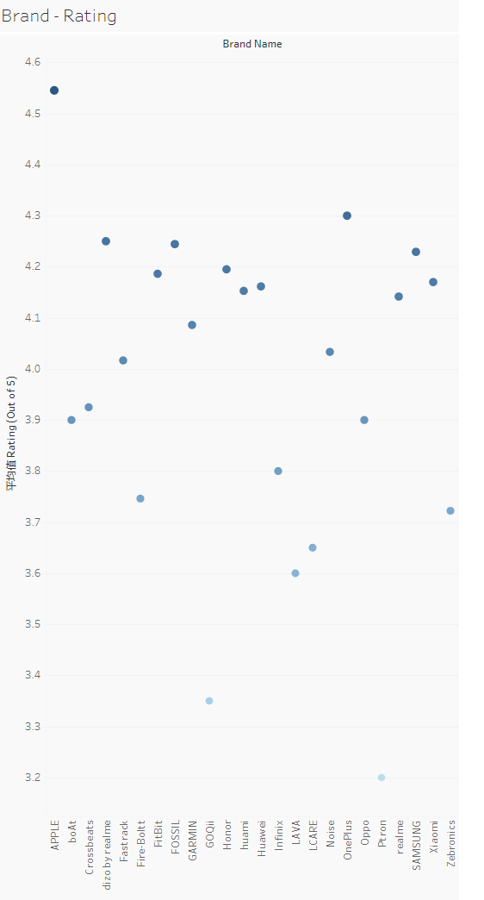

2nd Graph

The height of the bar in the figure represents the average original price of each brand, and the original price shows the difference in the original price more clearly through the difference in the width of the bar. Darker bars indicate higher selling prices. The average value of Apple's original price and selling price is the highest among all brands. The relatively low original price and selling price of OnePlus, which has high user ratings, may also be one of the reasons for its user satisfaction.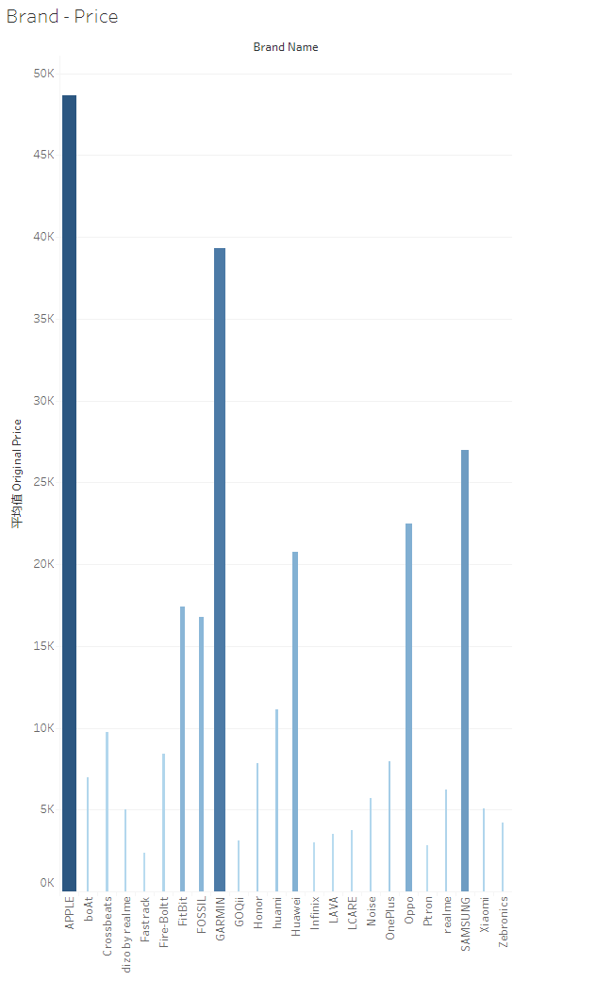

3rd Graph

The chart in Chapter 3 shows the types of device types owned by each brand. For example, Apple only has a watch, while FitBit has both a watch and a band.

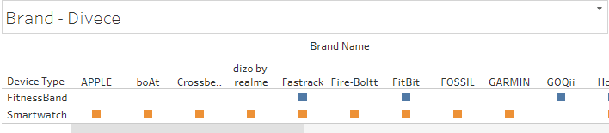

4th Graph

Battery life is also a common concern for users. Darker bars represent better battery life.